***« After graduate school, what do I do? »***

**Thinking Outside the Box**

*Join our roundtable discussion to learn about possible post-graduate careers that are off the beaten path, and that include science communication!*

**our guest speakers**

**Claudie Noël**

*B.Sc. in microbiology; M.Sc. in nanotoxicology/immunology; certificate in projet management and the life sciences entrepreneurship development program.*

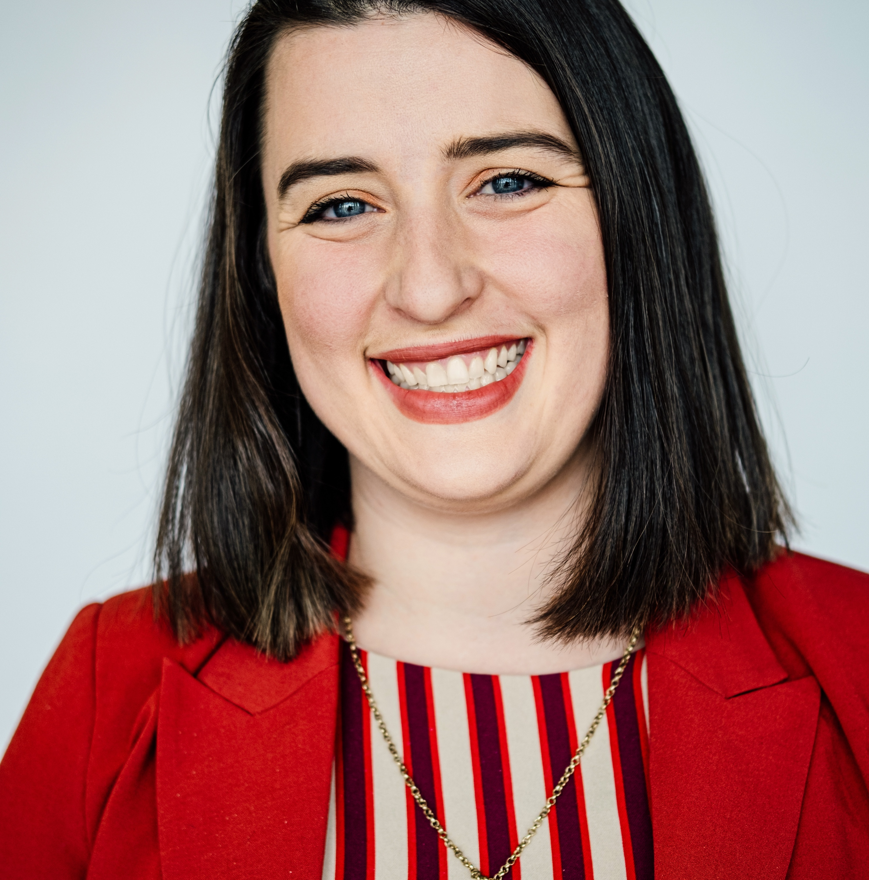

**Atelier 4 – in person**

**thursday, june 30, 2022**

**9 am – 11 am**

**registration required**

<https://bit.ly/3ahhuFK>

**Address**

*Gingras Pavillon*

*Amphithéâtre Saputo*

(6300 Av. de Darlington, Montréal, QC H3S 2J4 )

Member of the Montreal InVivo team, Claudie is responsible for projects related to the next generation of scientists, skills and talent development and bio-manufacturing.

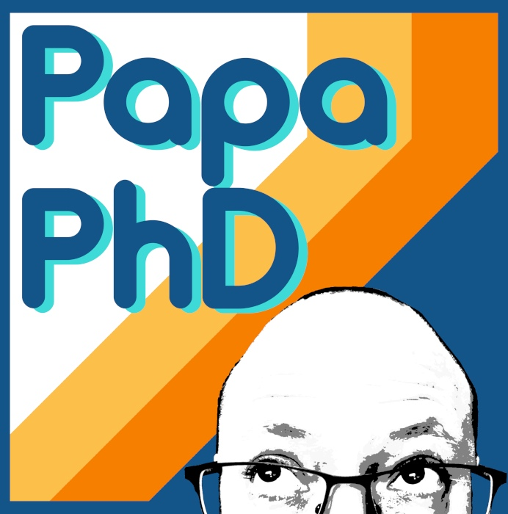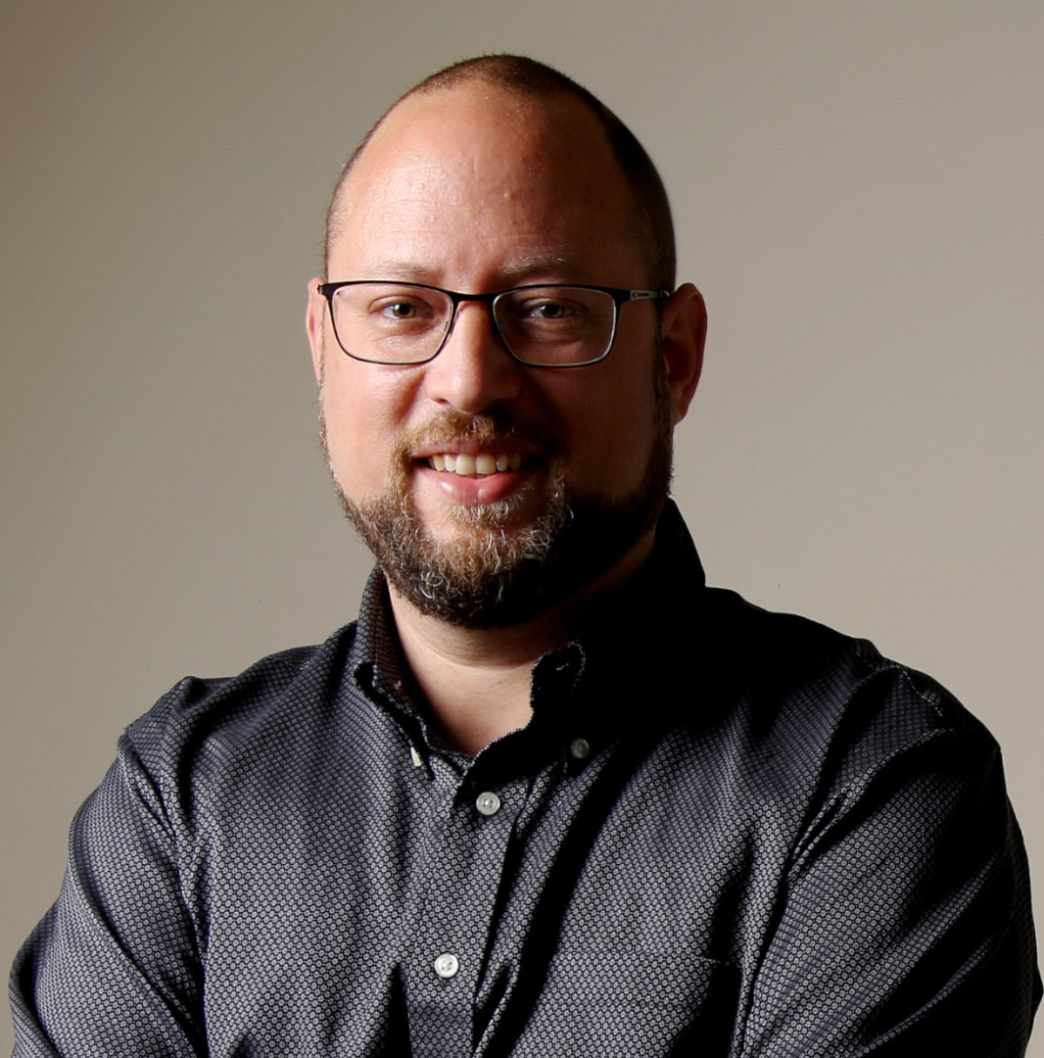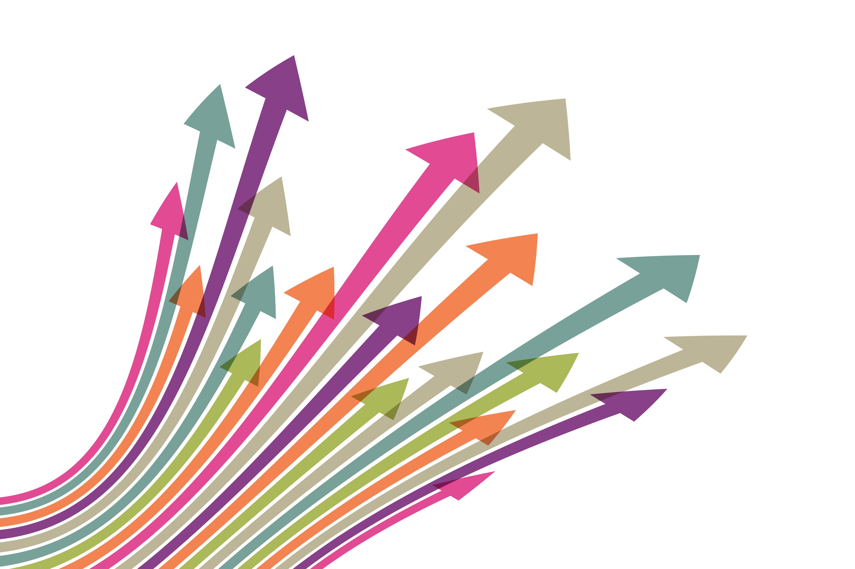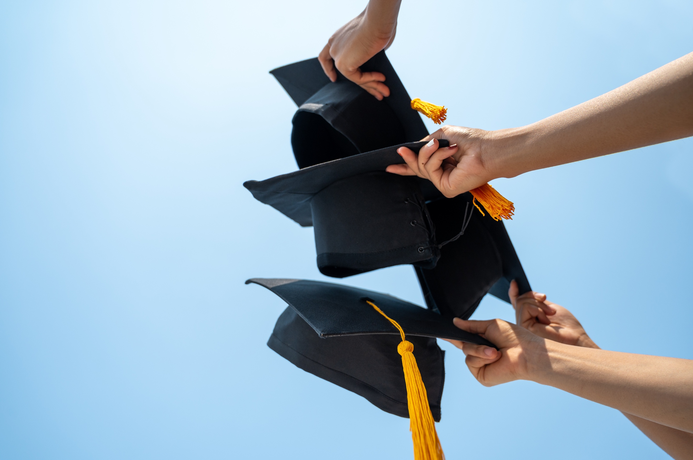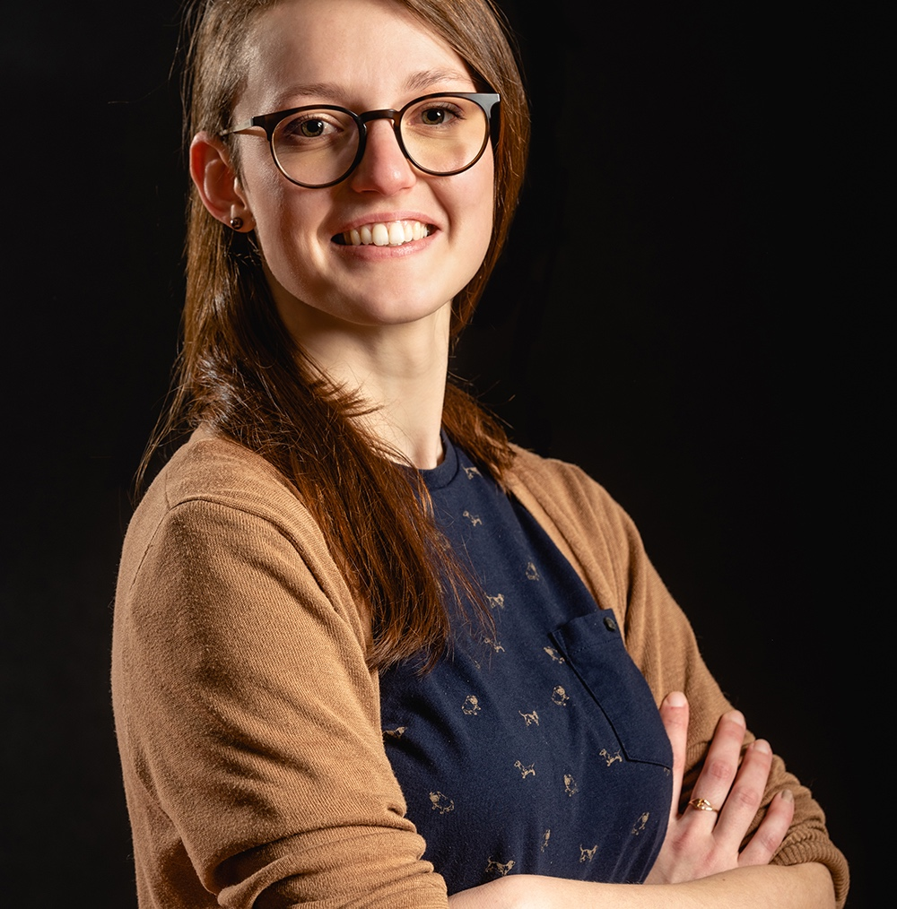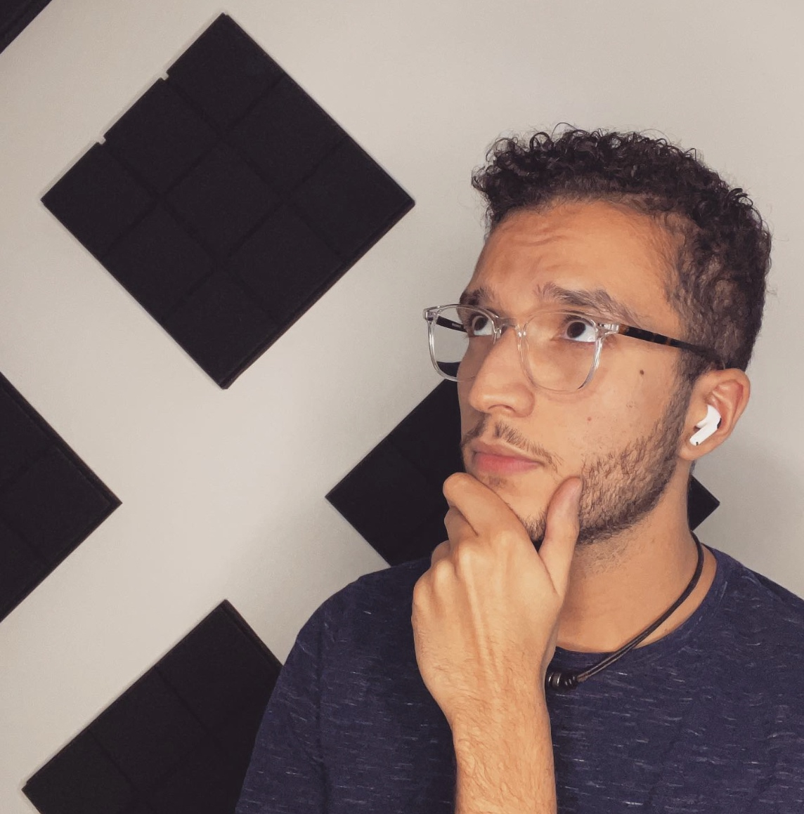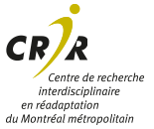

**David Mendes**

*PhD in Cell Biology (Université de Coimbra & Université McGill).*

After a stint in the medical communications industry, he built a career in specialized language services and co-founded PhDesign, a media agency dedicated exclusively to promoting research to society. Creator and host of the bilingual podcast Papa PhD where, in conversation with people from a wide variety of backgrounds, he tries to shed some light on the different career paths that master's and PhD graduates follow.

**Elyas Aissia**

*B.SC. in Natural Products Chemistry (Chicoutimi); M.Sc. of Science in Ecotoxology at the INRS.*

**members of the student committee**

Jeff Ferreri, Choumous Mannoubi, Bernat de las Heras, Shirley Dumassais, Nicole C. George, Charlotte Hendryckx, Julie Robidoux, Roya Khalili, Chantal Kreidy

Today, surrounded by a great team, her mission is to accompany scientists and technological entrepreneurs to make their projects shine, thanks to striking visuals and quality communication. Together, they develop trainings to improve the scientific communication of each one and the mastery of digital tools. In parallel, she is involved as a mentor for students (CBS, Canadian Biomaterials Society), occasionally accompanies budding entrepreneurs, and is a member of the Research Ethics Committee at CÉGEP Garneau

**Emilie Dubois**

*Ph.D. in cellular and molecular biology (Université Laval).*

Elyas is an early career science communicator involved in the Canadian initiative LaSciencedAbord. After participating in ComSciCon-QC 2021, he launched LaSciencedAbord in French, an initiative dedicated to fighting misinformation online, which has 60,000 cumulative subscribers. Elyas now collaborates with several science communicators and organizations to create infographics, videos, and online events.

➔ Visit www.CRIR.ca for more information on the activities of the CRIR Student Committee.