PRESS RELEASE

CRIR: recipient of FRQ research grants!

Montreal, June 16, 2022 – The Fonds de recherche du Québec (FRQ) has awarded more than $9M to the CRIR community to propel research.

The Scientific Directors of the Centre for Interdisciplinary Research in Rehabilitation of Greater Montreal (CRIR) is grateful and honoured to be able to participate in the advancement of research in Quebec and to be part of the #communauté FRQ, thanks to the grant of more than $6.7M confirmed for the upcoming five years as part of its infrastructure renewal from the Fonds de Recherches du Québec-Santé (FRQS). This award is also possible thanks to additional research funds awarded by the Stratégie québécoise de recherche et d'investissement en innovation (SQRI2).

Congratulations to our research members who received over $1.4M in FRQ awards, including $1.2M in FRQS Career Grants and Wage Subsidies (Dahlia Kairy, Frédérique Poncet, Marc Roig Pull and Aliki Thomas), $244,900 in FRQS research grants (Catherine Fichten, $165,000) and FRQNT research grants (Rémy Allard and Andrei Nejur, $79,000).

CRIR's next generation of scientists (14 students) was also awarded more than $920,000 in research or training scholarships. This funding will support the training and research careers of CRIR students.
Congratulations to the research members and the CRIR student community!

Join your voice to ours and let's propel the research together!

– 30 –

About CRIR
The Centre for Interdisciplinary Research in Rehabilitation of Greater Montreal (CRIR) is a unique research center that is distinguished by the excellence, breadth and diversity of its research in rehabilitation, as well as through its interdisciplinary, intersectoral and knowledge mobilization initiatives. These initiatives have an important impact in the clinical, scientific, public and community sectors. CRIR provides an extraordinary environment for the training of new researchers, and is also a model of partnership and administrative synergy.

The Pôle universitaire en réadaptation (PUR) has ensured the collaborative governance of CRIR since 2000, through the association of four CISSS/CIUSSS:
- CIUSSS du Centre-Sud-de-l’Île-de-Montréal: Institut universitaire sur la réadaptation en déficience physique de Montréal (IURDPM)
- CIUSSS West-Central Montreal: Lethbridge-Layton-Mackay Rehabilitation Centre;
- CISSS de Laval: Jewish Rehabilitation Hospital;
- CISSS de la Montérégie-Centre: Institut Nazareth et Louis-Braille.

The team counts 95 researchers divided into two research axes, more than 153 clinician/health members who collaborate on various research projects and over 460 students.

It is thanks to all these actors that CRIR has been one of the largest research centers in rehabilitation in Canada for 20 years!

Source: CRIR
Contact: Brigitte Fillion, Assistant to the Scientific Directors of CRIR and PUR
bfillion.crir@ssss.gouv.qc.ca

For its activities, CRIR benefits from the support of:

Funding University Affiliations

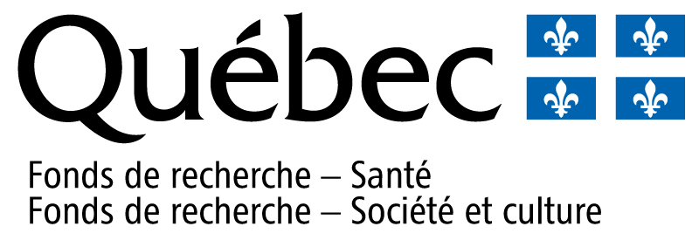

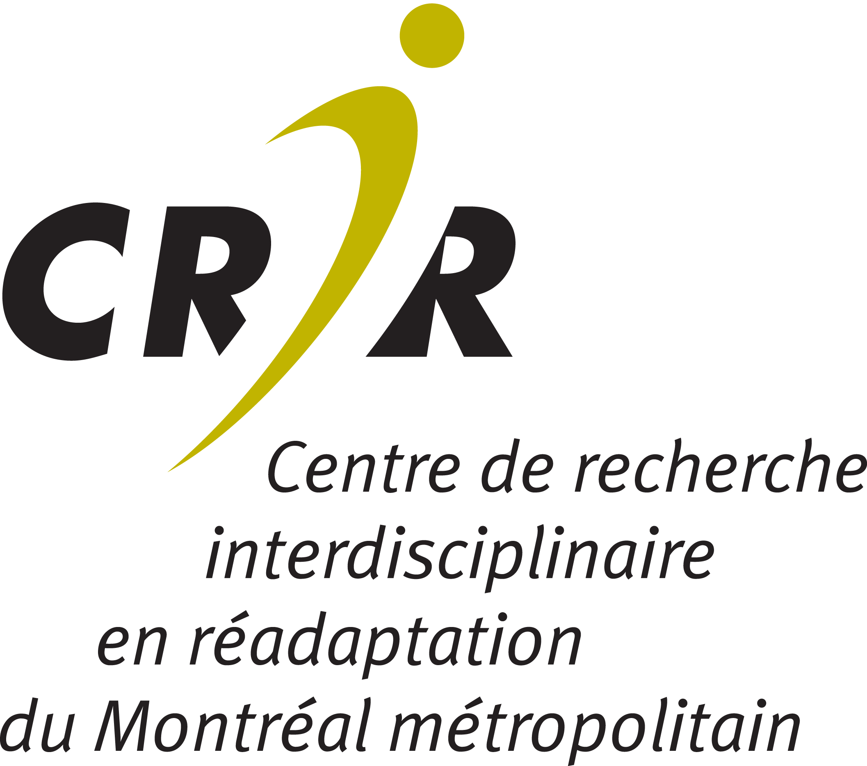

Suivez-nous | Follow us

