PRESS RELEASE

Development Plan 2022-2028
CRIR receives an exceptional rating from the FRQS!

Montreal, June 28, 2022 – The Fonds de recherche du Québec - Santé (FRQS) has awarded the CRIR Development Plan 2022-2028 an "exceptional" rating, in addition to increasing its funding to more than $6.7M for the renewal of its infrastructure over the next five years.

The Scientific Directors of the Centre for Interdisciplinary Research in Rehabilitation of Greater Montreal (CRIR) is proud to share this "exceptional" rating, the highest possible, following the evaluation of its 2022-2028 development plan submitted in December 2022 and covering the following points:

- The Centre’s organization and management
- Research activities
- Research training
- Collaborations and outreach
- Knowledge mobilization

In their report, members of the FRQS evaluation committee described CRIR's work as excellent and essential, aiming to develop new knowledge related to the rehabilitation and inclusion process of people with disabilities. The committee members also emphasized the organizational and governance structure of CRIR as being exemplary. Moreover, they believe that CRIR's development plan is consistent with its goal of excellence in interdisciplinary and intersectoral research. More specifically, its scientific programming stands out as being solid and highly relevant, with a clear focus on knowledge mobilization with the clinical community.

The committee members commended the CRIR’s diverse team of researchers, the work involving partners, the productivity of its members, the knowledge mobilization activities and the work of students. Finally, they were impressed by the quality of the discussions held with the 92 people present during the February 2022 evaluation visit, which they deemed "impeccable”.

The total grant of more than $6.7M, confirmed by the FRQS as part of the renewal of CRIR's infrastructure for the next five years, was made possible thanks to additional funds allocated by the Stratégie québécoise de recherche et d'investissement en innovation (SQRI2).

This enhancement will make it possible to develop a rehabilitation innovation ecosystem, to integrate in our organizational culture issues relating to the principles of equity, diversity, inclusion and accessibility (EDI-A) and the UN Sustainable Development Goals, in addition to fostering inter-centre collaborations, intersectoral networking and international outreach.

It should be recalled that the CRIR development plan was completed thanks to the exceptional mobilization of many stakeholders, including the CRIR infrastructure team, the research, clinical and student members, as well as our valuable partners from universities, CISSS, CIUSSS and foundations.

Sincere thanks and congratulations to all!

Join your voice to ours and let's propel the research together!

– 30 –
About CRIR
The Centre for Interdisciplinary Research in Rehabilitation of Greater Montreal (CRIR) is a unique research center that is distinguished by the excellence, breadth and diversity of its research in rehabilitation, as well as through its interdisciplinary, intersectoral and knowledge mobilization initiatives. These initiatives have an important impact in the clinical, scientific, public and community sectors. CRIR provides an extraordinary environment for the training of new researchers, and is also a model of partnership and administrative synergy.

The Pôle universitaire en réadaptation (PUR) has ensured the collaborative governance of CRIR since 2000, through the association of four CISSS/CIUSSS:
- CIUSSS du Centre-Sud-de-l’Île-de-Montréal: Institut universitaire sur la réadaptation en déficience physique de Montréal (IURDPM);
- CIUSSS West-Central Montreal: Lethbridge-Layton-Mackay Rehabilitation Centre;
- CISSS de Laval: Jewish Rehabilitation Hospital;
- CISSS de la Montérégie-Centre: Institut Nazareth et Louis-Braille.

The team counts 95 researchers divided into two research axes, more than 153 clinician/health members who collaborate on various research projects and over 460 students.

It is thanks to all these actors that CRIR has been one of the largest research centers in rehabilitation in Canada for 20 years!

Source: CRIR
Contact: Brigitte Fillion, Assistant to the Scientific Directors of CRIR and PUR
bfillion.crir@ssss.gouv.qc.ca

For its activities, CRIR benefits from the support of:

Funding University Affiliations

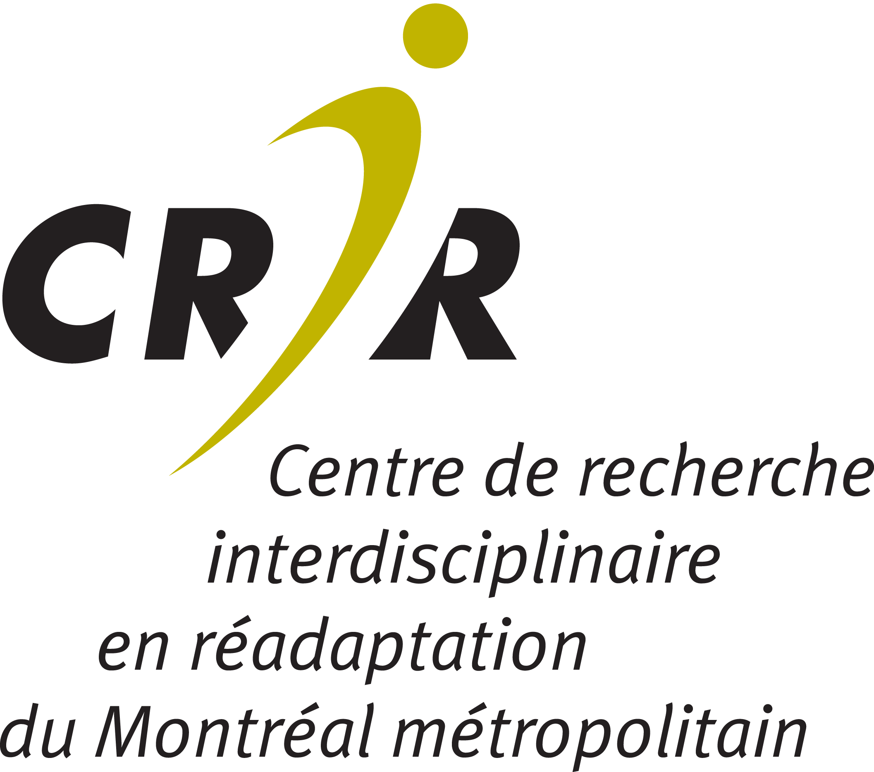

Suivez-nous | Follow us

