PRESS RELEASE

Results: 2022 CRIR Student Scolardships

Montreal, August 9, 2022 – The Scientific Direction of the Centre for Interdisciplinary Research in Rehabilitation of Greater Montreal (CRIR) is proud to offer 13 scholarships to CRIR students for a total amount of $177,000.

CRIR's Scientific Direction offers annual scholarships at the master's ($8,000), doctoral ($15,000) and postdoctoral ($20,000) levels to students supervised by regular CRIR researchers, including international students and those from other Canadian provinces.

For the 2022 competition, more than sixty applications were carefully analyzed by the scientific evaluation committee composed of 20 CRIR members (14 regular researchers and 6 postdoctoral fellows). The quality of the applications received allowed the committee to recommend 13 scholarships.

For a third consecutive year, AGE-WELL NCE joined CRIR in co-fund a scholarship to outstanding individual who wished to begin, continue or maintain her training or research program in the areas of scientific expertise shared by both organizations.

CRIR's Scientific Directors are pleased to present the 2022 recipients:

Postdoctoral scholarships ($20,000):
- Roua Walha*, under the supervision of Sylvie Nadeau (Axis 1) CRIR-IURDPM, CIUSSS du Centre-Sud-de-l’Île-de-Montréal, Université de Montréal;
- Sakiko Yamaguchi, under the supervision of Keiko Shikako-Thomas (Axis 2) CRIR-LLMRC, CIUSSS West-Central Montreal, McGill University.

Ph.D. Scholarships ($15,000):
- Rebecca Ataman under the supervision of Aliki Thomas (Axis 2), CRIR-JRH, CISSS de Laval, McGill University;
- Gabrielle Aubin, under the supervision of Walter Wittich (Axis 1), CRIR-INLB, CISSS de la Montérégie-Centre, Université de Montréal;
- Bernat de las Heras, under the supervision of Marg Roig Pull (Axis 1), CRIR-JRH, CISSS de Laval, McGill University;
- Rose Elekanachi, under the supervision of Laurie Snider (Axis 2), CRIR-JRH, CISSS de Laval, McGill University;
- Brent Rosenstein, under the supervision of Maryse Fortin (Axis 1), CRIR-LLMRC, CIUSSS West-Central Montreal, Concordia University;
- Mallory Ryan, under the supervision of Dana Anaby (Axis 2), CRIR-LLMRC, CIUSSS West-Central Montreal, Université McGill;
- Zhiyang Shi, under the supervision of Shane Sweet (Axis 2), CRIR-JRH, CISSS de Laval, McGill University.

Master of Research Scholarships ($8,000):
- Tessah Dunn, under the supervision of Laurie Snider (Axis 2), CRIR-JRH, CISSS de Laval, McGill University;
- Ebrahim Mahmoudi Kojidi, under the supervision of Keiko Shikako-Thomas (Axis 2) CRIR-LLMRC, CIUSSS West-Central Montreal, McGill University;
- Tosin Omonye Ogedengbe, under the supervision of Walter Wittich (Axis 1), CRIR-LLMRC, CIUSSS West-Central Montreal, Université de Montréal;
- Élie Tremblay under the supervision of Ingrid Verduickt (Axis 2), CRIR-IURDPM, CIUSSS du Centre-Sud-de-l’Île-de-Montréal, Université de Montréal.

*Recipient of AGE-WELL NCE-CRIR Scholarship

Also, our sincere thanks to the members of the scientific evaluation committee who shared their expertise, invested their time evaluating the submissions, and demonstrated their professionalism when making decisions:
Regular CRIR researchers:
Rémy Allard (CRIR-INLB, UdeM), Marie-Hélène Boudrias (CRIR-JRH, McGill), Alain Steve Comtois (CRIR-IURDPM, UQAM), Julie Côté (CRIR-JRH, McGill), Geoff Dover (CRIR-LLMRC, Concordia), Marie-Josée Levert (CRIR-IURDPM, UdeM), Mélissa Park (CRIR-JRH, McGill), Frédérique Poncet (CRIR-LLMRC, McGill), Richard Preuss (CRIR-LLMRC, McGill), Maurice Ptito (CRIR-INLB, UdeM), Shawn Robbins (CRIR-LLMRC, McGill), Annie Rochette (CRIR-IURDPM, UdeM), Natacha Trudeau (CRIR-IURDPM, UdeM), Ingrid Verduickt (CRIR-IURDPM, UdeM).

Postdoctoral Students:
Karine Latulippe (CRIR-JRH, McGill), Ana Paula Da Silva Salazar (CRIR-IURDM, UdeM), Karla Vanessa Rodrigues Soares Menezes (CRIR-IURDPM, UdeM), Alexandra Tessier (CRIR-JRH, McGill), Atul Jaiswal (CRIR–INLB, UdeM), Jordan Herbison (CRIR-JRH, McGill).

References:
Lethbridge-Layton-Mackay Rehabilitation Centre (LLMRC) | Jewish Rehabilitation Hospital (JRH) | Institut Nazareth et Louis-Braille (INLB) | Institut universitaire sur la réadaptation en déficience physique de Montréal (IURDPM) | Université de Montréal (UdeM) | Université du Québec à Montréal (UQAM) | Concordia University (Concordia) | McGill University (McGill).

Congratulations to all recipients and their research supervisors!

– 30 –
About CRIR
The Centre for Interdisciplinary Research in Rehabilitation of Greater Montreal (CRIR) is a unique research center that is distinguished by the excellence, breadth and diversity of its research in rehabilitation, as well as through its interdisciplinary, intersectoral and knowledge mobilization initiatives. These initiatives have an important impact in the clinical, scientific, public and community sectors. CRIR provides an extraordinary environment for the training of new researchers, and is also a model of partnership and administrative synergy.

The Pôle universitaire en réadaptation (PUR) has ensured the collaborative governance of CRIR since 2000, through the association of four CISSS/CIUSSS:
- CIUSSS du Centre-Sud-de-l’Île-de-Montréal: Institut universitaire sur la réadaptation en déficience physique de Montréal (IURDPM);
- CIUSSS West-Central Montreal: Lethbridge-Layton-Mackay Rehabilitation Centre;
- CISSS de Laval: Jewish Rehabilitation Hospital;
- CISSS de la Montérégie-Centre: Institut Nazareth et Louis-Braille.

The team counts 95 researchers divided into two research axes, more than 153 clinician/health members who collaborate on various research projects and over 460 students.

It is thanks to all these actors that CRIR has been one of the largest research centers in rehabilitation in Canada for 20 years!

Source: CRIR
Contact: Brigitte Fillion, Assistant to the Scientific Directors of CRIR and PUR
bfillion.crir@ssss.gouv.qc.ca

For its activities, CRIR benefits from the support of:

Funding University Affiliations

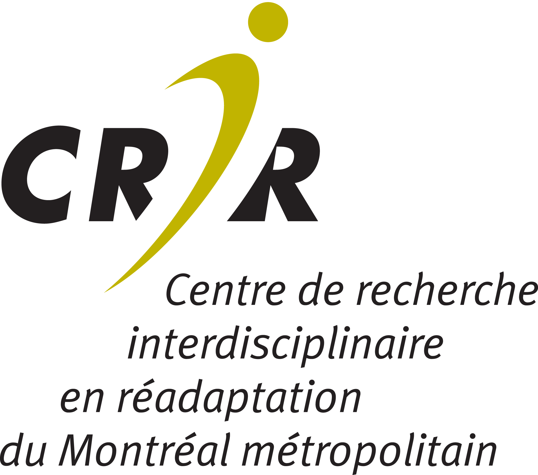

Suivez-nous | Follow us

