PRESS RELEASE

Researcher Sylvie Nadeau,
recipient of the Acfas Adrien-Pouliot 2022 Award

Montreal, November 25, 2022 - Researcher Sylvie Nadeau (CRIR-IURDPM), honoured at the 78th edition of the ACFAS 2022 Gala.

The 78th edition of the Association canadienne-française pour l'avance des sciences (ACFAS) Gala was held yesterday in Montreal. This event, which also marked the 100th anniversary of the association, celebrated the excellence of research in our society and in the francophone world.

During the evening, the prestigious "Acfas Adrien-Pouliot 2022" award was presented to researcher Sylvie Nadeau.

The Scientific Directorate of the Centre de recherche interdisciplinaire en réadaptation du Montréal métropolitain (CRIR) is proud to highlight Sylvie's exceptional career in rehabilitation.
Sylvie Nadeau
Full professor at the School of Rehabilitation of the Université de Montréal and researcher at the Pathokinesiology Laboratory of the CRIR-Institut universitaire sur la réadaptation en déficience physique de Montréal (IURDPM) of CIUSSS du Centre-Sud-de-l'Île-de-Montréal.

The Réseau provincial de recherche en adaptation-réadaptation (REPAR) and the Ingénierie de technologies interactives en réadaptation (INTER) group join CRIR in congratulating the recipient! This great distinction illustrates remarkably well her career and her leadership in research and we are very proud to count her in the great scientific community of CRIR.

Acfas Adrien-Pouliot Award: Award for Scientific Cooperation with France
This prize was created in 2000 and named in honour of Adrien Pouliot, mathematician, former president of Acfas and winner of numerous French awards. It is awarded to a researcher in recognition of the excellence and influence of his or her work and actions carried out in collaboration with France. This award is sponsored by the Consulate General of France in Quebec City and the Ministère des Relations internationales et de la Francophonie.

Join your voice to ours and let's propel the research together.

– 30 –

About CRIR
The Centre for Interdisciplinary Research in Rehabilitation of Greater Montreal (CRIR) is a unique research center that is distinguished by the excellence, breadth and diversity of its research in rehabilitation, as well as through its interdisciplinary, intersectoral and knowledge mobilization initiatives. These initiatives have an important impact in the clinical, scientific, public and community sectors. CRIR provides an extraordinary environment for the training of new researchers, and is also a model of partnership and administrative synergy.

The Pôle universitaire en réadaptation (PUR) has ensured the collaborative governance of CRIR since 2000, through the association of four CISSS/CIUSSS:
- CIUSSS du Centre-Sud-de-l’Île-de-Montréal: Institut universitaire sur la réadaptation en déficience physique de Montréal (IURDPM)
- CIUSSS West-Central Montreal: Lethbridge-Layton-Mackay Rehabilitation Centre
- CISSS de Laval: Jewish Rehabilitation Hospital
- CISSS de la Montérégie-Centre: Institut Nazareth et Louis-Braille
The team counts more than 95 researchers divided into two research axes, more than 150 clinician/health members who collaborate on various research projects and over 450 students.

It is thanks to all these actors that CRIR has been one of the largest research centers in rehabilitation in Canada for 20 years!

Source: CRIR
Contact: Scientific Directors of CRIR
administration.crir@ssss.gouv.qc.ca

For its activities, CRIR benefits from the support of :

Funding University Affiliations

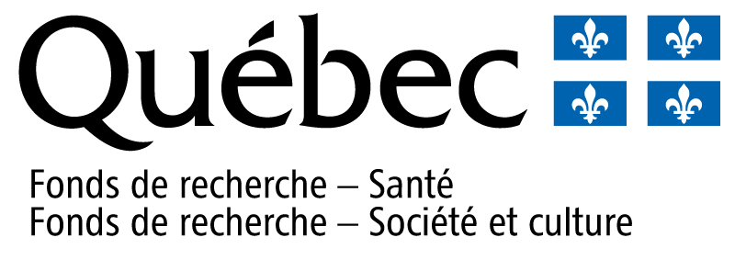

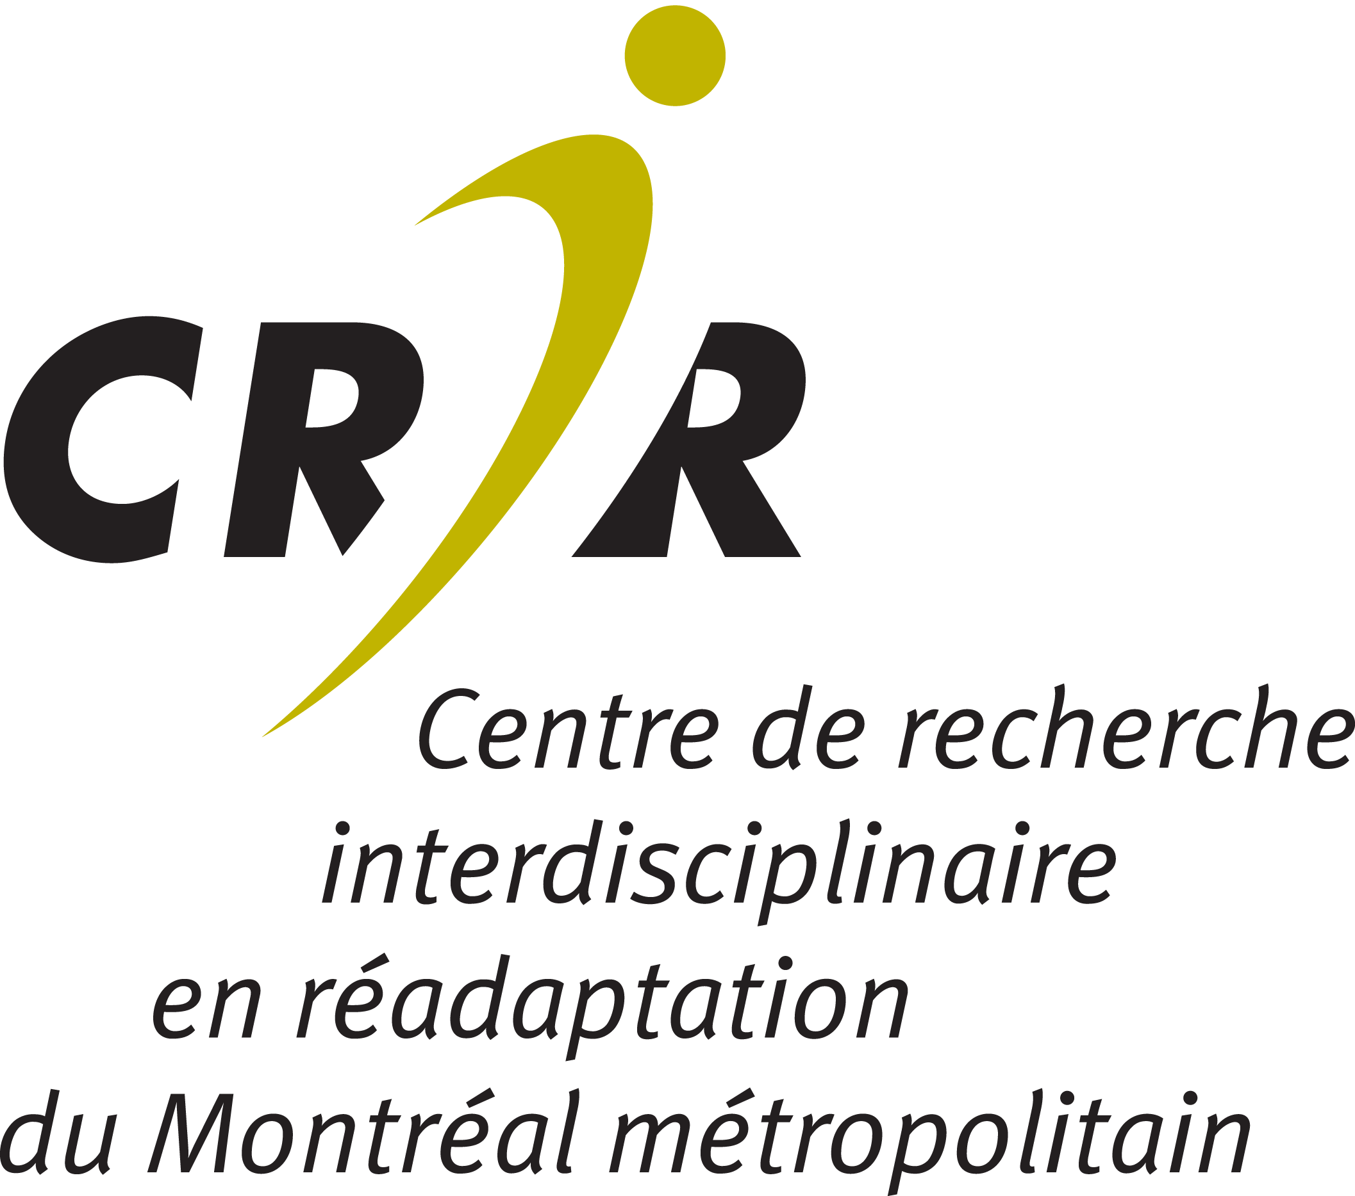

Suivez-nous | Follow us

