

**Thursday September 28** 11h30-12h45

He is a professor in the Department of social and preventive medicine at Université Laval and a researcher in the Axis population health and best practices, CHU de Québec research centre. A long-time ally of First Nations and Inuit communities, his research focuses on cultural perspectives on health and disease. He is the director of the Qanuikkat Siqinirmiut project, the first population-based survey on the health of Inuit in southern Quebec.

She is an occupational therapist working with Inuit communities in Nunavik since 2017. Recently graduated from the master of public health at Université Laval, her areas of interest focus on the healthy development of Inuit children in urban areas and cultural safety in health and social services, particularly rehabilitation.

**Chantal Robillard, DAARE, CIUSSS West-Central**

Chantal.robillard.mab@ssss.gouv.qc.ca

**Language :**

Conference in French

**Contact :**

Santé et bien-être des *Siqinirmiut* (Inuit du Sud) : Regard sur les besoins et les ressources visant à soutenir la communauté inuit urbaine du sud du Québec (presentation in French)

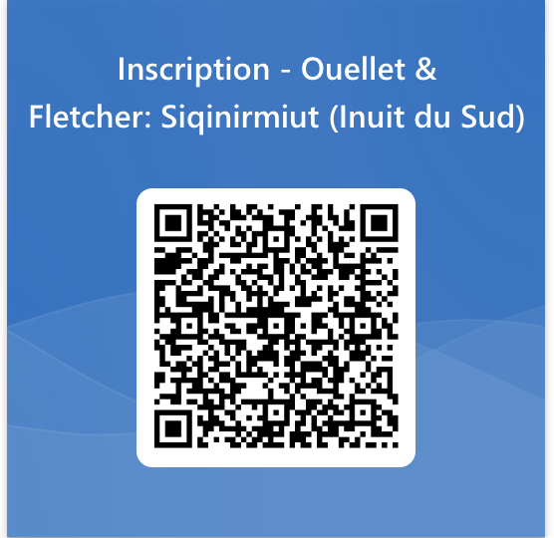

**Registration :** [**REGISTRATION**](https://forms.office.com/Pages/ResponsePage.aspx?id=KP7hBotfdUC_bK4kvhp5ksaLsyqRXpxNnMjTJMO0N1NUN01GUThDRzFCNVVMR0RZT0pJS0NKWkhVRS4u)

More and more Inuit are living temporarily or permanently in urban areas across Canada. In Quebec, it is estimated that around 20% of Inuit live outside Nunavik. However, despite the growing proportion of Inuit living in urban areas, studies about them remain limited. In addition, health services designed for Inuit living in the South are virtually non-existent. To fill these gaps, the Qanuikkat Siqinirmiut? research project has set itself the goal of building knowledge on the Siqinirmiut and supporting the development of resources and services specific to this community. The aim of this conference is to present the main results of the Qanuikkat Siqinirmiut? project, as well as a study on supporting the healthy development of urban Inuit children, also part of this project. Finally, the conference will present the Qavvivik clinic, a family and community health center for urban Inuit that recently opened its doors in Montreal.

**Lauriane Ouellet, OT**

Professor, Department of social and preventive medicine, Université Laval

**Christopher Fletcher, Ph.D.**

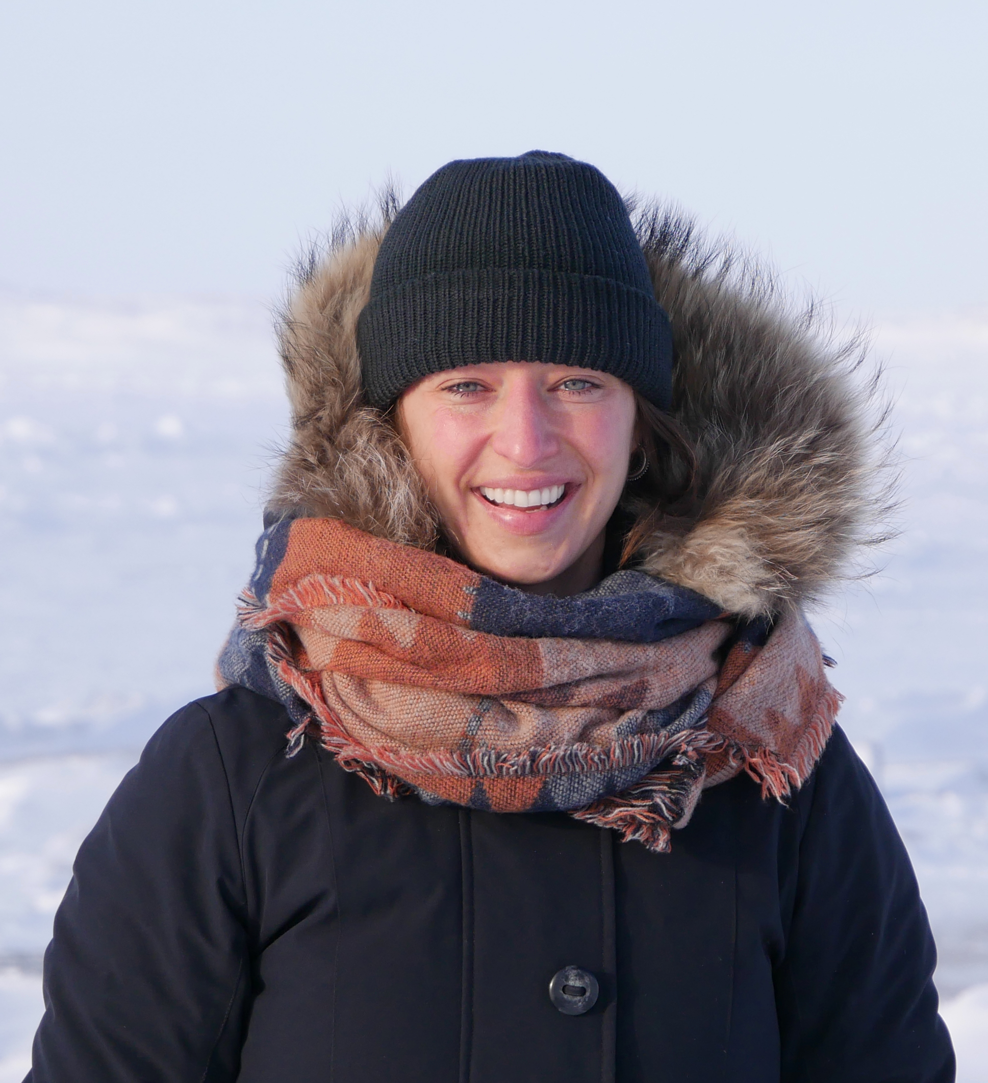

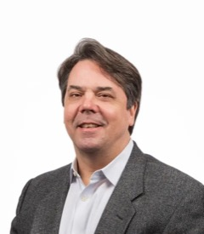

 

Online, Zoom

**Where :**

Conference given by Lauriane Ouellet & Christopher Fletcher on health and well-being of *Siqinirmiut* (Southern Inuit)

Scientific Conference CRIR

Presentation of Savoirs Réadaptation, Academic affairs & research ethics

Centre de recherche interdisciplinaire

en réadaptation du Montréal métropolitain

**Date & time :**

**Date et heure :**

Ocupational therapist & masters of public health, Université Laval