Appointment to CRIR's administrative headquarters

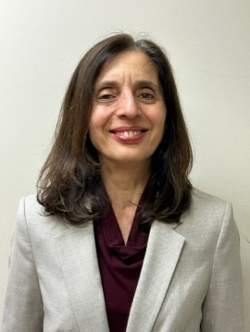
Virginia Cornea, Ph.D.
Coordinator of the EDIA Committee

Montreal, November 20, 2023

CRIR's scientific direction is pleased to announce that Virginia Cornea will continue her involvement with CRIR as coordinator of the Equity, Diversity, Inclusion and Accessibility (EDIA) committee.

Virginia's mandate is to support the EDIA committee in the implementation of actions in line with the committee's various objectives, to establish communications with CRIR members, to monitor the various indicators, to assist scientific directors in drafting reports and other related tasks.

vIRGINIA CORNEA
Virginia is a neuroscientist, having worked in basic research on neurobiological systems defined by their neurotransmitter.

After obtaining her PhD from Université de Montréal, she went on to complete a post-doctorate at McGill University in experimental research on neuropathic pain.

Her interest in clinical research led her to become involved in a number of innovative projects, including the multicenter project on the impact of Covid-19 on the delivery of rehabilitation care.

Virginia has been providing occasional support to CRIR for several months now. You can reach her by e-mail at vcornea.crir@ssss.gouv.qc.ca.

The entire CRIR family wishes her every success in the fulfillment of her mandate.

