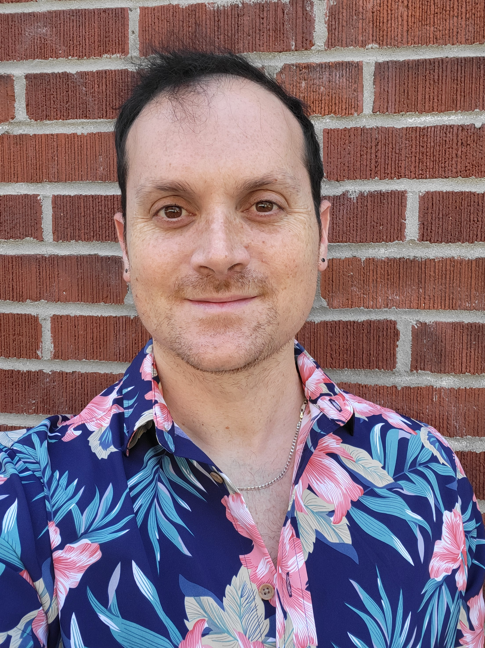

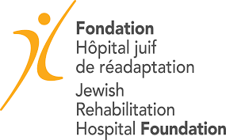
This presentation is open to all CISSS de Laval rehabilitation programs. During this interactive presentation, where participants will be able to interact via electronic surveys and question-and-answer periods, the impact of stroke on sexuality will be discussed. Then, the factors that positively and negatively influence clinical practices in sexual rehabilitation will be presented. Finally, the process of co-designing and implementing knowledge transfer tools on sexuality, developed over the past 7 years, will be presented. Preliminary results from recent projects will also be presented.
Conference abstract

Louis-Pierre is an occupational therapist who worked for 5 years in intensive functional rehabilitation with neurological clients, particularly stroke survivors. He holds a master's degree and a doctorate in rehabilitation sciences from Université de Montréal, and is now a postdoctoral researcher at McGill University under the supervision of Prof. Aliki Thomas, Ph.D. Louis-Pierre's work focuses on the themes of sexuality, disability, and improving the training and practices of healthcare professionals in relation to sexuality.
Louis-Pierre Auger, erg., PhD
Ergothérapeute/Occupational Therapist
Stagiaire postdoctoral/Postdoctoral Fellow, Institute of Health Sciences Education, McGill University
Centre de recherche interdisciplinaire en réadaptation du Montréal métropolitain
Président de la Clinique des bourses de l'Université de Montréal Ph.D.

Date & Time :
June 11, 2025
12:00 - 13:00

Modality : Hôpital juif de réadaptation, chambre D1004 et ZoomHôpital juif de réadaptation, chambre D1004 et ZoomHôpital juif de réadaptation, chambre D1004 et ZoomHôpital juif de réadaptation, chambre D1004 et Zoom
Hybride
Mireia.Carrillo.cissslav@ssss.gouv.qc.ca

◼️ In person: Jewish Rehabilitation Hospital, Room D 1004

Please confirm your presence: Mireia.Carrillo.cissslav@ssss.gouv.qc.ca
or
◼️ Virtual: On Zoom. Please register:
https://us02web.zoom.us/meeting/register/SjYG_fFPR_OJhurjz8tn7Q

Language :
French
Integrating sexuality into rehabilitation - the example of 7 years of collaboration with stroke rehabilitation in Quebec
Presented by:
Jewish Rehabilitation Hospital (JRH), CISSS de Laval

As part of the "Talking Research" series | Presentations by researchers, postdoctoral fellows or clinicians on the findings of their research projects
sur les résultats de projets de recherche.

Contact :
CRIR
Scientific Conference

Centre de recherche interdisciplinaire
en réadaptation du Montréal métropolitain
Date et heure :

