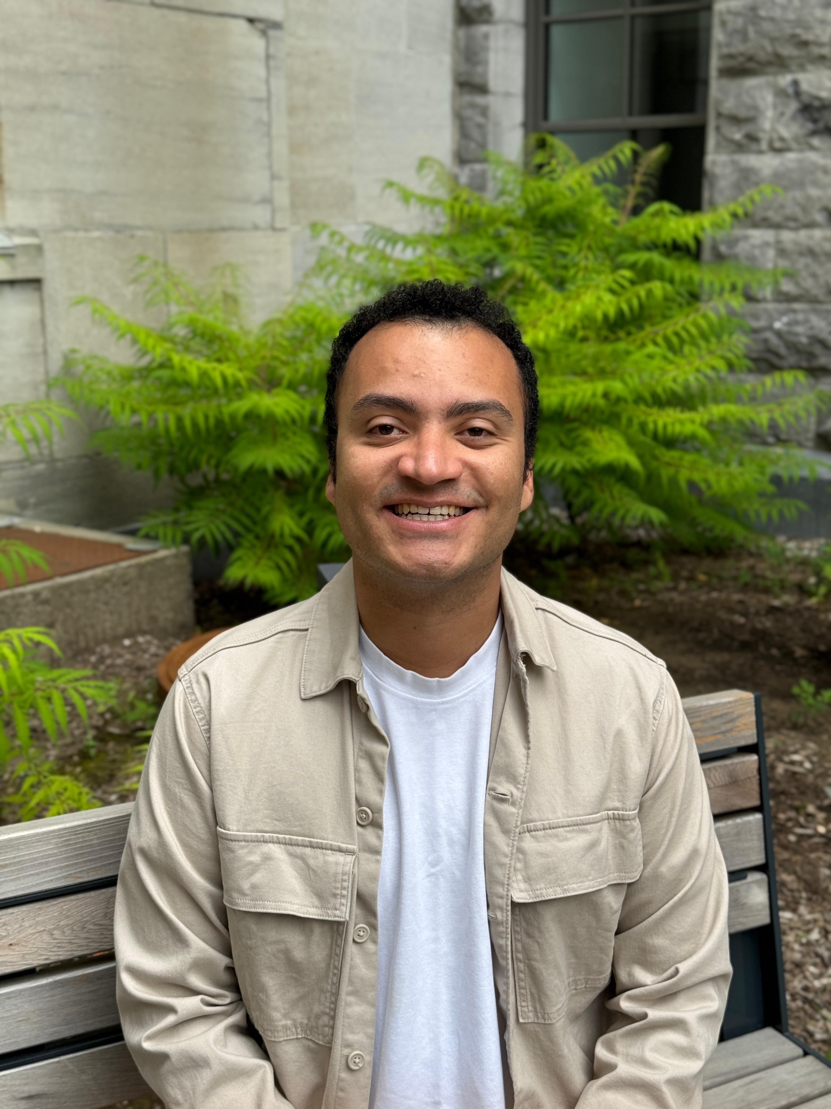
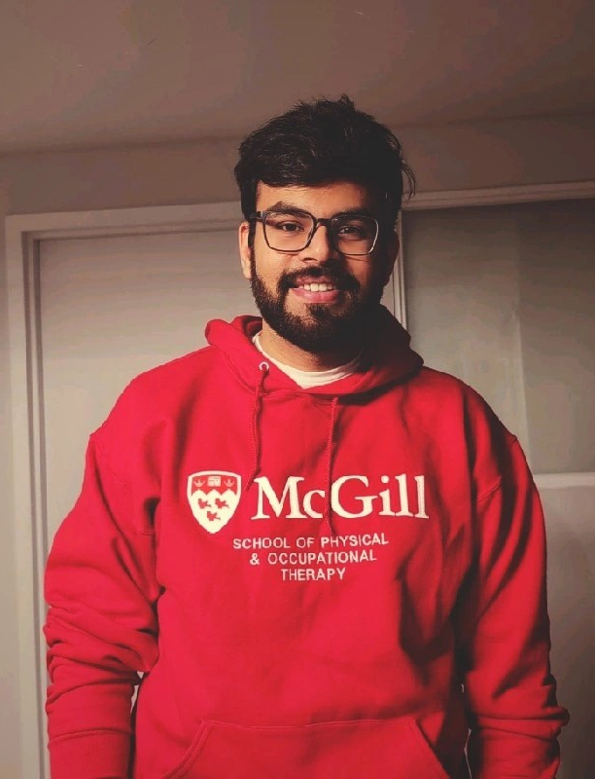


Centre de recherche interdisciplinaire
en réadaptation du Montréal métropolitain
CRIR
Scientific Conference

Presented by:
Jewish Rehabilitation Hospital (JRH), CISSS de Laval

As part of the "Talking Research" series | Presentations by researchers, postdoctoral fellows or clinicians on the findings of their research projects
sur les résultats de projets de recherche.

Thiago Vidal Pereira
MSc Rehabilitation Science (Thesis) student
McGill University, School of Physical and Occupational Therapy
Saksham Gupta
B.PT, MSc Rehabilitation Science (Thesis) student,
McGill University, School of Physical and Occupational therapy
Thiago Vidal Pereira is an MSc student in Rehabilitation Sciences at McGill University’s School of Physical & Occupational Therapy. His main research interests focus on the role of multisensory integration, motor behaviour, and functional outcomes in shaping recovery and performance. He is currently investigating human steering behaviour while walking and turning on an omnidirectional treadmill with virtual reality, aiming to clarify how this setup affects locomotion.

Saksham Gupta is pursuing a research-based MSc in Rehabilitation Science (thesis) at McGill University. His work focuses on advancing neurorehabilitation and geriatric rehabilitation, with a particular emphasis on integrating immersive technology to enhance therapeutic outcomes. He is currently exploring human locomotion through the use of augmented reality (AR) and virtual reality (VR) to improve evaluation and training methods for complex locomotor tasks.
Date & Time :
September 16, 2025
12:00 - 13:00

Modality : Hôpital juif de réadaptation, chambre D1004 et ZoomHôpital juif de réadaptation, chambre D1004 et ZoomHôpital juif de réadaptation, chambre D1004 et ZoomHôpital juif de réadaptation, chambre D1004 et Zoom
Hybride
Mireia.Carrillo.cissslav@ssss.gouv.qc.ca

◼️ In person: Jewish Rehabilitation Hospital, Room D 1004

Please confirm your presence: Mireia.Carrillo.cissslav@ssss.gouv.qc.ca
or
◼️ Virtual: On Zoom. Please register:
https://us02web.zoom.us/meeting/register/uAeRRcChRIyBgwRFaqDXlQ

Language :
English
Contact :
Date et heure :
-Effects of an omnidirectional treadmill with virtual reality on gait and body segment reorientation during walking and turning.
-Walking across realities – Comparing overground obstacle avoidance strategies in Augmented, Virtual and Physical reality in response to a static pedestrian

Thiago Vidal Pereira
Conference: Effects of an omnidirectional treadmill with virtual reality on gait and body segment reorientation during walking and turning.

This presentation will explore how omnidirectional treadmills with virtual reality affect gait steering strategies. The study methods and research questions will be presented, followed by results on body segment reorientation onsets and amplitudes, walking speed, step length and cadence. The presentation will end with a discussion of what these results mean for gait research and rehabilitation.

Saksham Gupta
Conference: Walking across realities – Comparing overground obstacle avoidance strategies in Augmented, Virtual and Physical reality in response to a static pedestrian

This interactive presentation, open to all CISSS de Laval rehabilitation programs, will examine how different immersive technologies, virtual reality (VR) and augmented reality (AR), impact our locomotor behaviour while avoiding obstacles, and the perceptual and technological factors behind these changes. During this presentation, participants will have the opportunity to engage.
Thiago Vidal Pereira
MSc Rehabilitation Science (Thesis) student
McGill University, School of Physical and Occupational Therapy
Saksham Gupta
B.PT, MSc Rehabilitation Science (Thesis) student,
McGill University, School of Physical and Occupational therapy
-Effects of an omnidirectional treadmill with virtual reality on gait and body segment reorientation during walking and turning.
-Walking across realities – Comparing overground obstacle avoidance strategies in Augmented, Virtual and Physical reality in response to a static pedestrian

Date & Time :
September 16, 2025
12:00 - 13:00
Modality : Hôpital juif de réadaptation, chambre D1004 et ZoomHôpital juif de réadaptation, chambre D1004 et ZoomHôpital juif de réadaptation, chambre D1004 et ZoomHôpital juif de réadaptation, chambre D1004 et Zoom
Hybride
Mireia.Carrillo.cissslav@ssss.gouv.qc.ca

◼️ In person: Jewish Rehabilitation Hospital, Room D 1004

Please confirm your presence: Mireia.Carrillo.cissslav@ssss.gouv.qc.ca
or
◼️ Virtual: On Zoom. Please register:
https://us02web.zoom.us/meeting/register/uAeRRcChRIyBgwRFaqDXlQ

Language :
English
Presented by:
Jewish Rehabilitation Hospital (JRH), CISSS de Laval

As part of the "Talking Research" series | Presentations by researchers, postdoctoral fellows or clinicians on the findings of their research projects
sur les résultats de projets de recherche.

Contact :
CRIR
Scientific Conference

Centre de recherche interdisciplinaire
en réadaptation du Montréal métropolitain
Date et heure :

