

information and consent form

For individuals requiring written support

- PROJECT TITLE

Promoting the use of public transportation by people with disabilities through participatory research.

- PROJECT MANAGERS

Philippe Archambault, erg., Ph.D  450 688-9550, poste 4832  philippe.archambault@mcgill.ca | 

- COLLABORATORS

Normand Boucher, Ph.D.  Claire Croteau, Ph.D.  Ahmed El-Geneidy, Ph.D.  Isabelle Gélinas, Ph.D.  Mathilde Le Bouëdec | Julie McIntyre, M.O.A.  Diane Morin, Ph.D.  Suhantee Sathananthan, M.Sc.  Alexandra Tessier, Ph.D. | 

- Partner institutions

- Société de transport de Montréal (STM) | 
- Autorité régionale de transport métropolitain (ARTM)  - CIUSSS du Centre-Sud-de-l’Île-de-Montréal  - CISSS de Laval |   

- FUNDING ORGANIZATION

This research project is funded by the Social Sciences and Humanities Research Council of Canada


- PREAMBLE

We want to know if you want to participate in a research project.

Take the time necessary to read the form. | 
Do not hesitate to ask your questions. | 

- PROJECT DESCRIPTION AND OBJECTIVES

This research studies the Inclusive Mobility training. This training is designed to train people with disabilities to use regular transportation. |   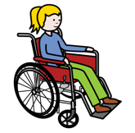  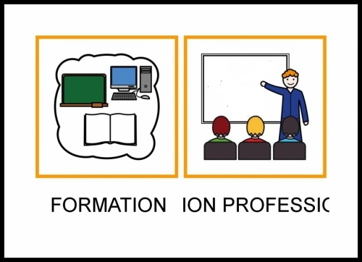
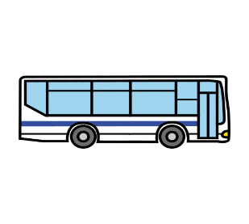

?
?
The research project aims to
- Assess the effects of the training.
- Evaluate the quality of the training

- NATURE OF PARTICIPATION

What ?  A questionnaire about you and one about your experience with transportation (e.g., name, age, gender).  Do you want to participate in more research?  If you wish, an individual interview will be conducted. |   

You will be asked questions about your transportation experiences and the training. | ?  ?  ?

How long does it take?  4 times 10 to 20 minutes for the questionnaire  - Once before the training  - Once after the training  - Once one month after the training  - Once three months after the training  3 times 30 to 45 minutes for the interview | 

- Once before the training
- Once after the training
- Once three months after the training
Where?  The questionnaire will be answered alone at home and returned by email.  You will decide where the interview takes place: | 

Home | Videoconference   |  |  | Research Center  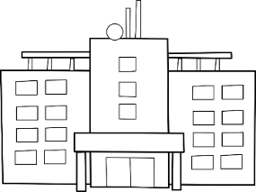
Can we contact you for the interviews ?

  Yes |   No
Do you want to participate in even more research?

We can contact you to participate in the following tests.

You won’t have to do the tests you do not like.

1.How strong your hand is. | 
2. How far you can walk in 6 minutes. | 
3. A test to see how well you think and remember things. | 
4.Questions about how confident you feel in doing things on your own. | 
5.Share your postal code (so we could see the number of accessible transports in your area).
6.Questions about your friendships and how you get along with others | 

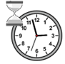
How long does it take?

The tests will be in 2parts, each lasting 25 minutes
Where?

Home |  | School   |  |  |  | Research center

Can we contact you for these tests?



Yes No

Your transportation organization collects data about you during your participation in the training.


Do you agree that the transportation organisation gives your data to us for the research project?

 | 
Yes | No
- BENEFITS OF YOUR PARTICIPATION

Feel better about using buses and the subway. | 
Help rehabilitation research

- RISKS AND DISADVANTAGES OF YOUR PARTICIPATION

RISKS

There is little danger.  - You could feel tired when we test your distance to walk or push your wheelchair for 6 minutes. If so, then you can take a break.  - You could also fall when we test your distance to walk. Someone will be with you to help you.  - You can request to stop being asked questions at any time.  - Your transportation services will not be affected. |       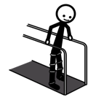
- The rehabilitation care you receive or will receive will not be affected.

DISADVANTAGES

The time to participate in the research
Traveling to the training
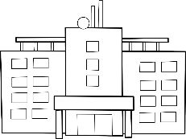

If any questions make you feel negative emotions, talk to me. I can direct you to people who can help you. | 

- ACCESS TO RESULTS AT THE END OF THE RESEARCH

Do you want to know the results at the end of the research? We will not share individual test results.
Yes | No
 E-Mail: _____________________________

- CONFIDENTIALITY

Your anonymity is always preserved.  Only the research team and a person from Research Ethics Committee en readaptation et en déficience physique can access your information. | 
The Zoom link will have a password, and the data will be stored on a secure cloud. | 
The data will be kept at the Jewish Rehabilitation Hospital and protected by a password.

Research data will be destroyed 5 years after the end of the project. | 
- VOLUNTARY PARTICIPATION AND RIGHT TO WITHDRAW
Your participation is voluntary.  You can stop at any time.  It's your choice. |   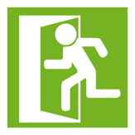
- Secondary use of information for research purposes

We may want to use the information you give us in this project for another research project. Would you agree that we use your data if ever it occurs?
Yes | No

- FUTURE STUDIES

I accept to be contacted again to offer me the opportunity to participate in other research projects by Philippe Archambault's team.

 Yes | No
For 1 year*
For 2 years*
For 3 years*

*Your personal contact information will be retained by the researchers for the chosen period.

- RESPOSIBILITY OF THE RESEARCH TEAM

By agreeing to participate in this study, you do not waive any of your rights, nor do you release the researchers or the institution from their civil and professional responsibilities. | 

- COMPENSATION ALLOWANCE

You will receive $50 in compensation for the constraints and inconveniences resulting from your participation in the research project.  If you leave before the end of the study, you will receive:  - $17 if you leave after completing the questionnaires once.  - $33 if you leave after completing the questionnaires twice.  You will receive an additional $50 if you participate in the interviews.  You will receive another 50$ if you participate to test your strength, distance of walk, thinking, social and motivation. |   
You will receive an Opus card valid for 3 months after the training. | 

- CONTACT PERSONS

Question on the research project?
Philippe Archambault  450-688-9550, poste 4832  philippe.archambault@mcgill.ca |     
Questions about your rights or your participation in a research project?

Research Ethics Committee
514-809-0230
cer.rdp.ccsmtl@ssss.gouv.qc.ca

Complaints ?
CIUSSS du Centre-Sud-de-l’Île-de-Montréal
514-593-3600
commissaireauxplaintes.ccsmtl@ssss.gouv.qc.ca

CISSS de Laval
450-668-1010, poste 23628

plaintes.csssl@ssss.gouv.qc.ca.

- CONSENT

I declare that I have read and understood this project, the nature and extent of my participation, as well as the risks and disadvantages to which I am exposed. | 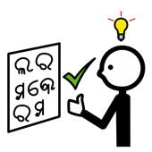 | 
I have had the opportunity to ask all questions regarding various aspects of the study and have received answers to my questions. | 
I can withdraw at any time without any prejudice. | 
I certify that I have been given ample time to make my decision. | 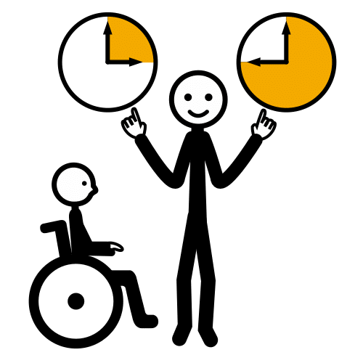
A signed copy of this information and consent form must be provided to me. | 
I, the undersigned, willingly agree to participate in this study.

PARTICIPANT NAME SIGNATURE

Done at ________________, on ___________, 20_____

THE RESEARCHER PROVIDES A SIGNED COPY OF THE CONSENT FORM TO THE PARTICIPANT AND KEEPS ONE IN THE RECORD.

- ASSENT
I understand what I will do in the research.

I can leave the research whenever I want.

I want to participate to the research

PARTICIPANT’S NAME SIGNATURE

Signed at : ________________, on ___________, 20_____

I, ……………., hereby confirm that I have explained to the above-mentioned child the nature of the research project and the known risks involved in participation in this research and that the parent(s) and child have the option of withdrawing from this study at any time. We have assured the child/the parents that despite the publication of the results of the study, the child’s identity will be kept confidential.

________________________________
Signature of the person in charge of the project
of her/his representative

Signed at ___________________, on _______________ 20____.

- RESEARCHER’S OR REPRESENTATIVE’S COMMITMENT

I, the undersigned, ___________________________________, certify that
(a) I have explained the terms of this form to the signatory;
(b) I have answered any questions they asked me about it;
(c) I have clearly indicated to them that they are free to withdraw from their participation in the research project described above at any time;
(d) I will provide them with a signed and dated copy of this form.

________________________________
Signature of the project manager or their representative

Done at ___________________, on _______________ 20____

